SERIAL KILLERS AND FBI PROFILERS

(for MOBS and Boss MOB)

Lawrence Bittaker and Roy Norris

“The Toolbox Killers”

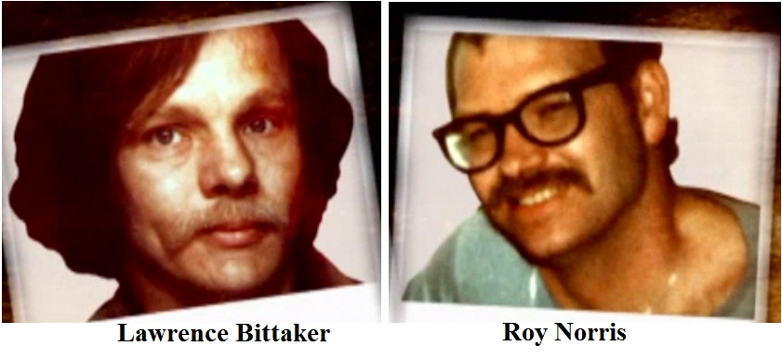

Overview:

Items:

Jeffrey Dahmer

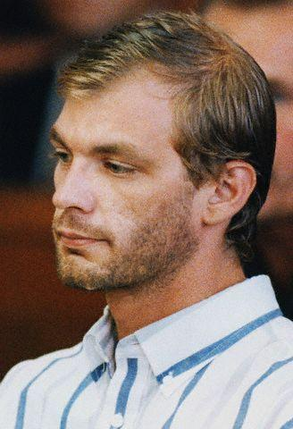

Overview:

Items:

Richard Ramirez

“The Night Stalker”



Overview:

Items:

Andre Chikatilo

“The Red Ripper”



Overview:

Items:

Richard Trenton Chase

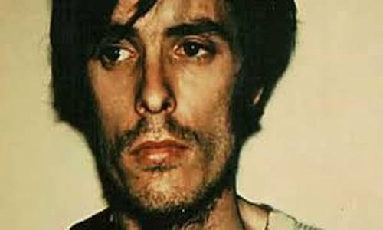

Overview:

Items:

Henry Lee Lucas

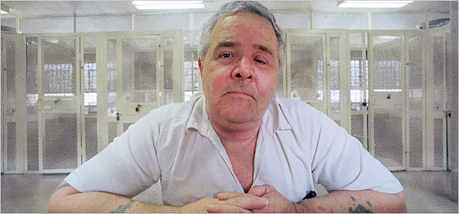

Overview:

Items:

Ed Gein

“Psycho”

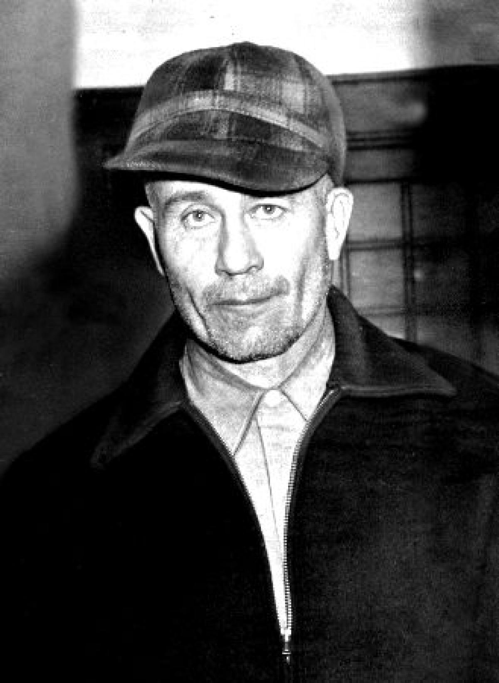

Overview:

Items:

Gary Ridgway

“The Green River Killer”



Overview:

Items:

Ted Bundy

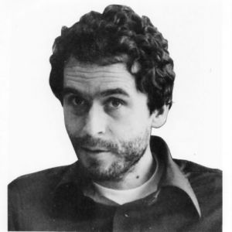

Overview:

Items:

John Wayne Gacy

“Killer Clown”

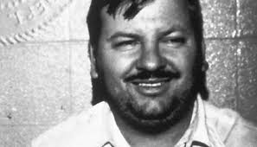

Overview:

Items:

Charles Schmid

“Pied Piper of Tucson”



Overview:

Items:

Richard Speck

Overview:

Items:

H.H. Holmes

Overview:

Items: